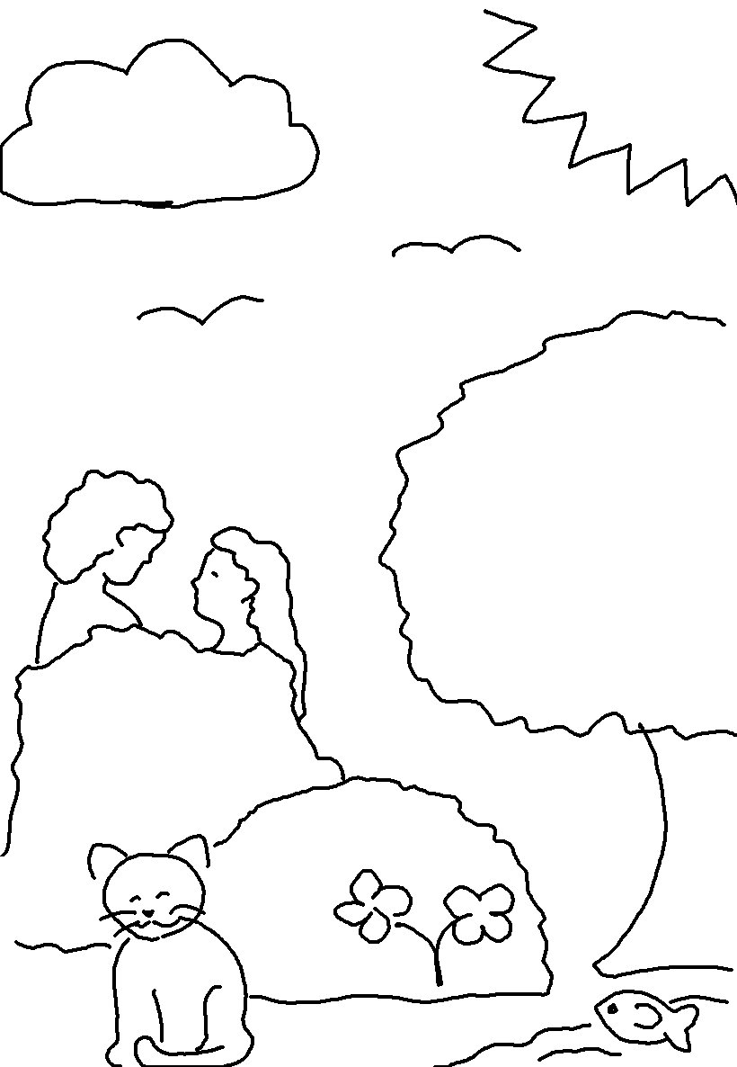
God said, "Let us make human beings in our image,
to be like us."
Genesis 1:26_{NLT}

